William Montague & Hamza Pediera

PageRank, 21241 Final Project

The PageRank algorithm is designed to rank an arbitrary number of website pages given to the algorithm based upon an iterative method that takes into account the number of the other websites listed that are linked into each website, using a Markov Matrix. PageRank uses links to each page, and the links to the pages which link to each page, to in a way organise random walks or varying length.

We use a damping factor, d, of 0.85, as was calculated as optimal for the pageRank algorithm. The damping factor is required in the use of the page rank algorithm to take into account user behavior that isn’t to a directly linked website. Thus, the damping factor represents the probability the user will continue following links directly. In addition, in a case where a page only links to itself (such that Mij = 1 and i = j) the damping factor prevents every value from collecting at that node as we do more iterations. An example of this is below, we call this a “SinkHole”.

Example 1 with 50 iterations “SinkHole”: SiteA = [0 1/3 1/3 1/3], SiteB = [0 1 0 0], SiteC = [1 0 0 0], SiteD = [1 0 0 0] for PageRank and HITS. The first image is a visual representation of this case.

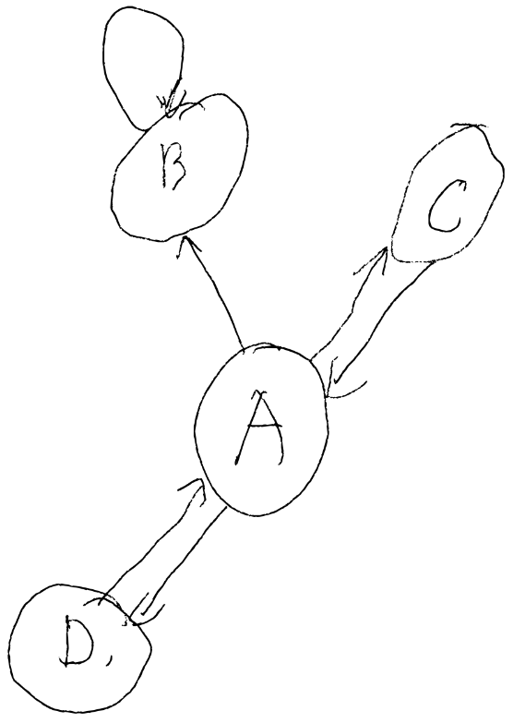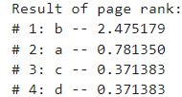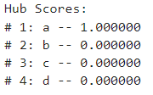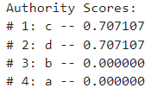

We can observe that the sinkhole website has a higher page rank because of the value collected. The hub and authority scores will be discussed later.

Mathematically, as page rank iterates it gets increasingly close to assigning each page a rank which is the sum of the ranks of the page pointing to it, divided by each page’s out degree, which is the number of pages which have a chance of linking to that page. This creates an endorsement based model which is far superior to the random.

Our PageRank Algorithm

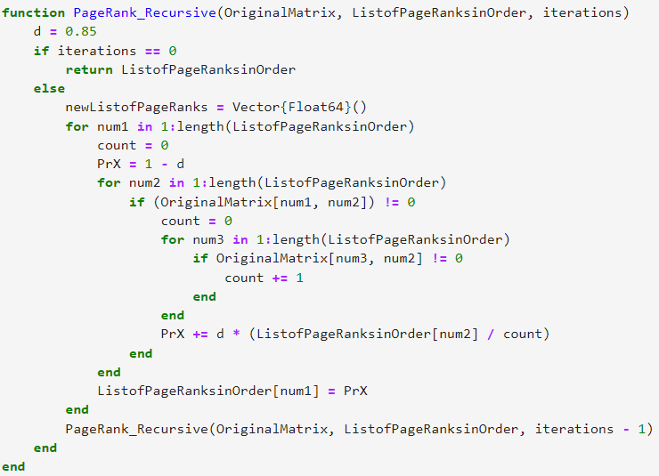

The HITS algorithm, also known as the hubs and authorities algorithm, is another algorithm for ranking websites, that assigns all websites both hub and authority values. Hubs can be thought of as large directories that aggregate information, and link to many other pages, whereas authorities represent pages that are linked to by many different hubs, and thus are likely reputable. By looking at the interaction between these two groups of websites, a more nuanced analysis of website authority and ranking can be established in these two different domains, often at the cost of computational power and efficiency.

The authority values of each webpage are the sum of the scaled hub values pointing to that page, and hub values are defined as the sum of the authority values of the web pages that it points to. Thus, these two values are recursively defined, because they are dependent on each other. The code for this algorithm is below.

Our HITS Algorithm

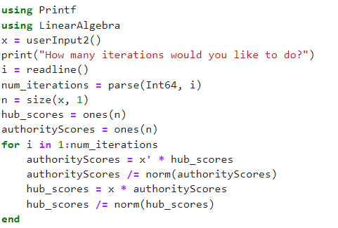

We applied both the PageRank algorithm and the HITS with user input options to allow the interface to be more friendly. It was similar for both, here is the code for the userInput of PageRank.

userInput Algorithm

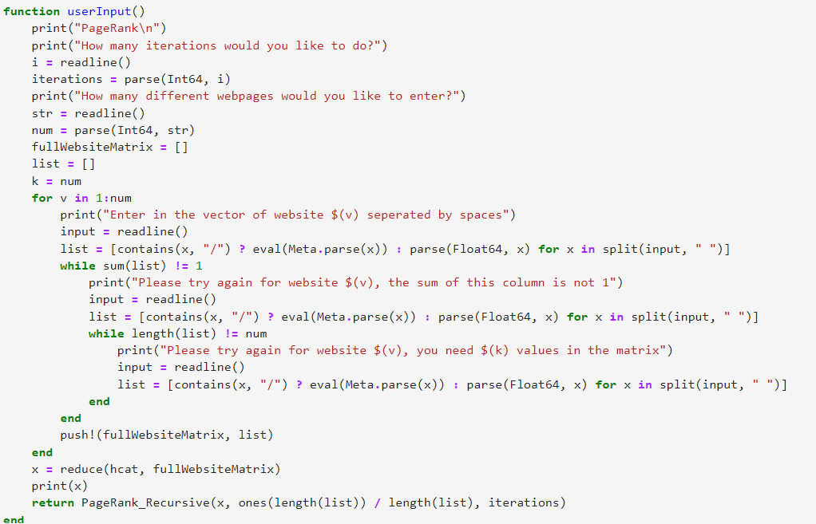

userInput Example Output

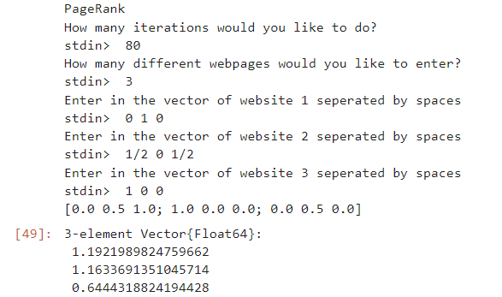

Here are some further examples using more complicated networks. As you can see, websites with more connections going into them often have higher authority scores, and websites with more connections going out of them often have higher hub scores.

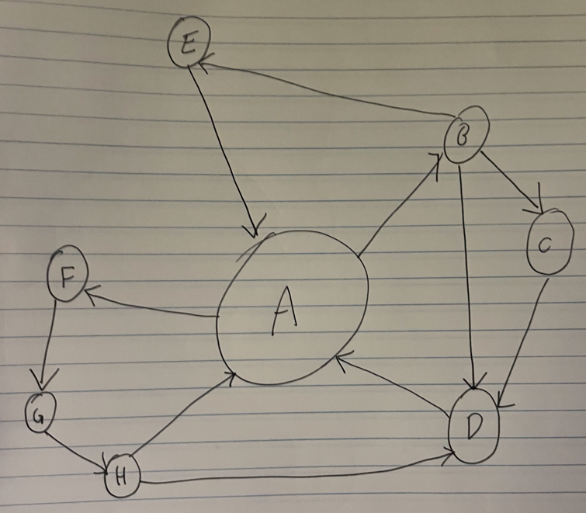

PageRank:

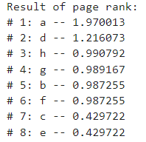**Example 2**

HITS:

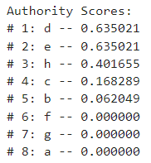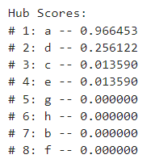

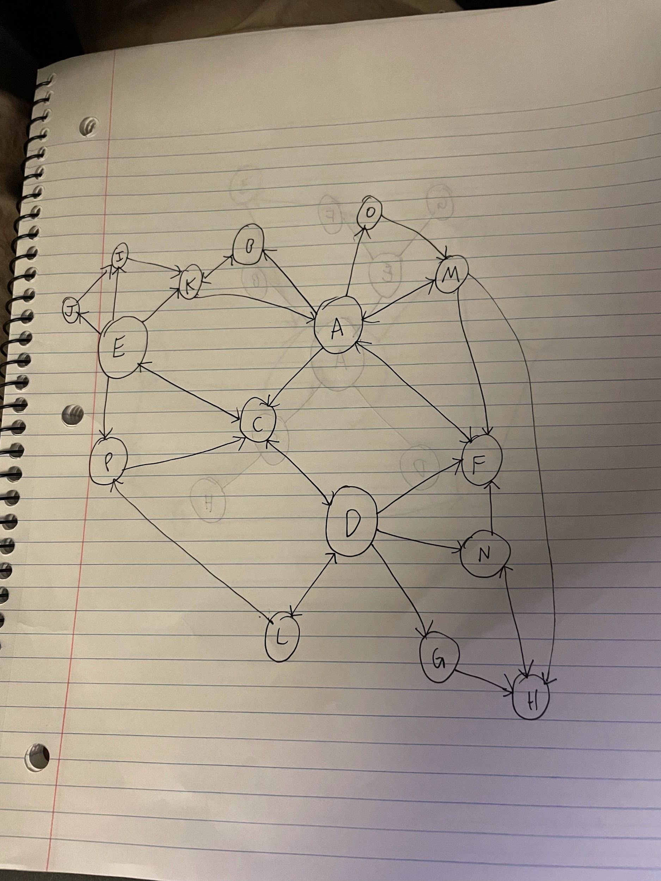

**Example 3**

PageRank:

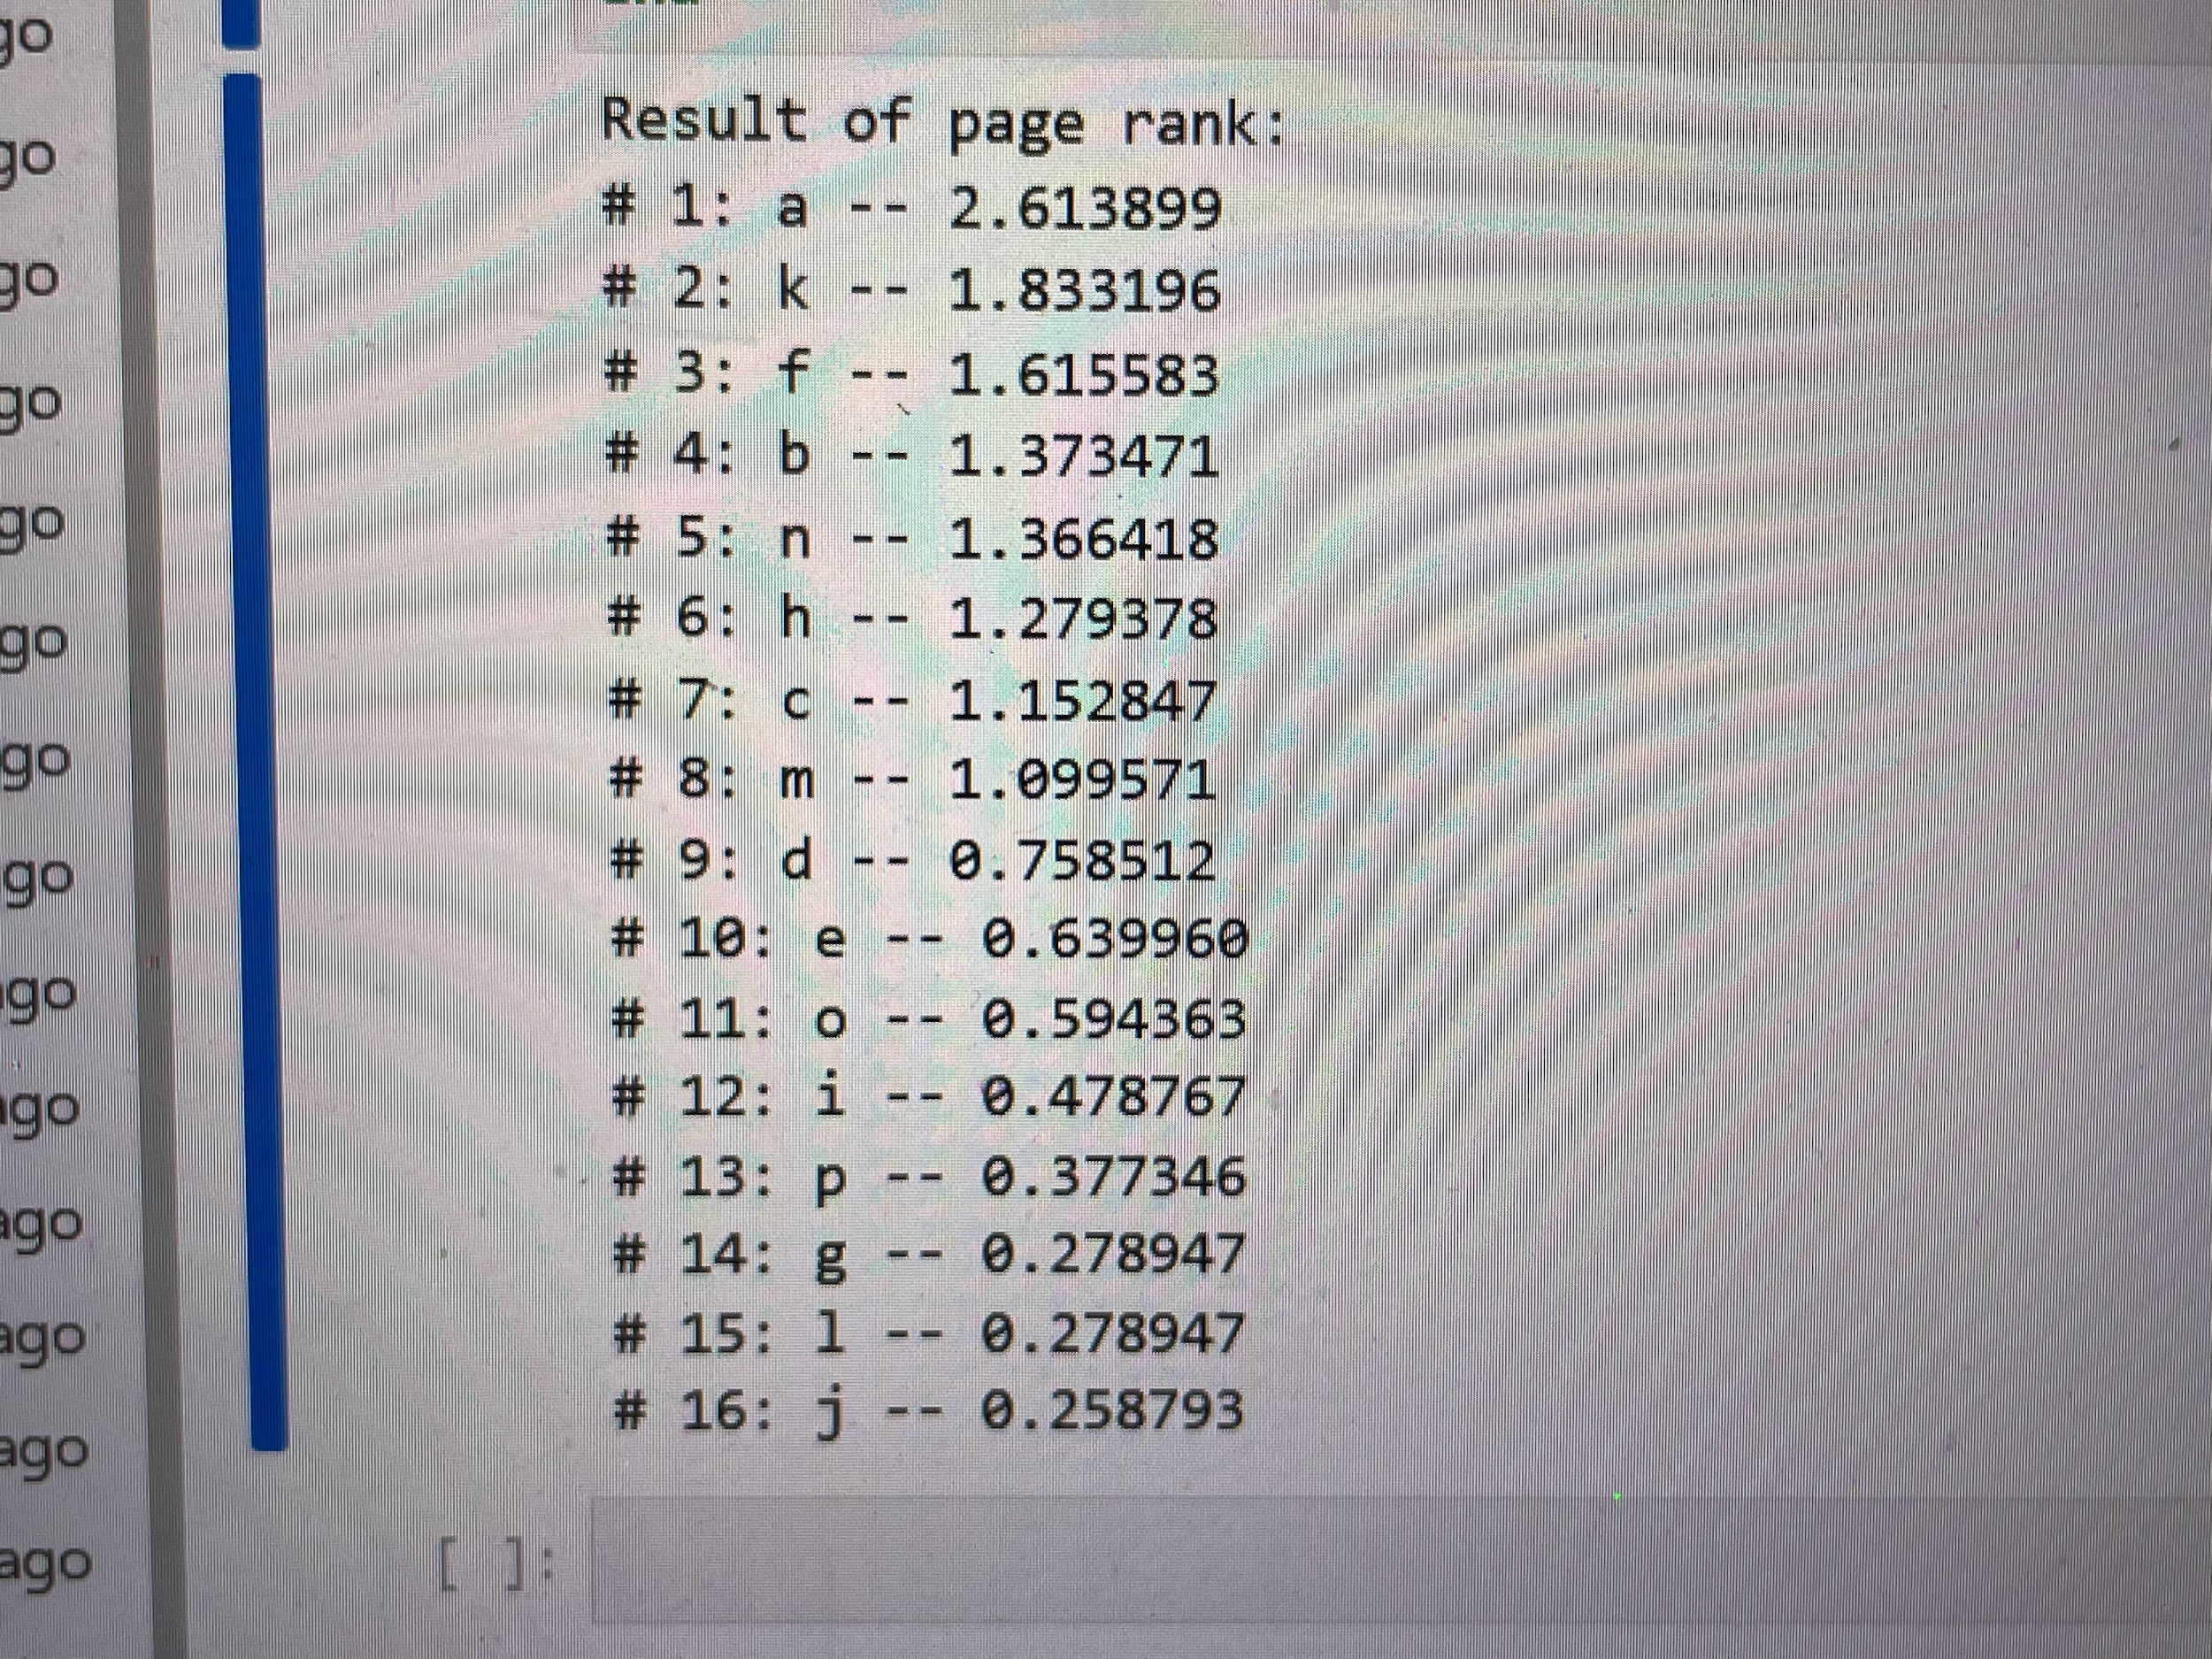

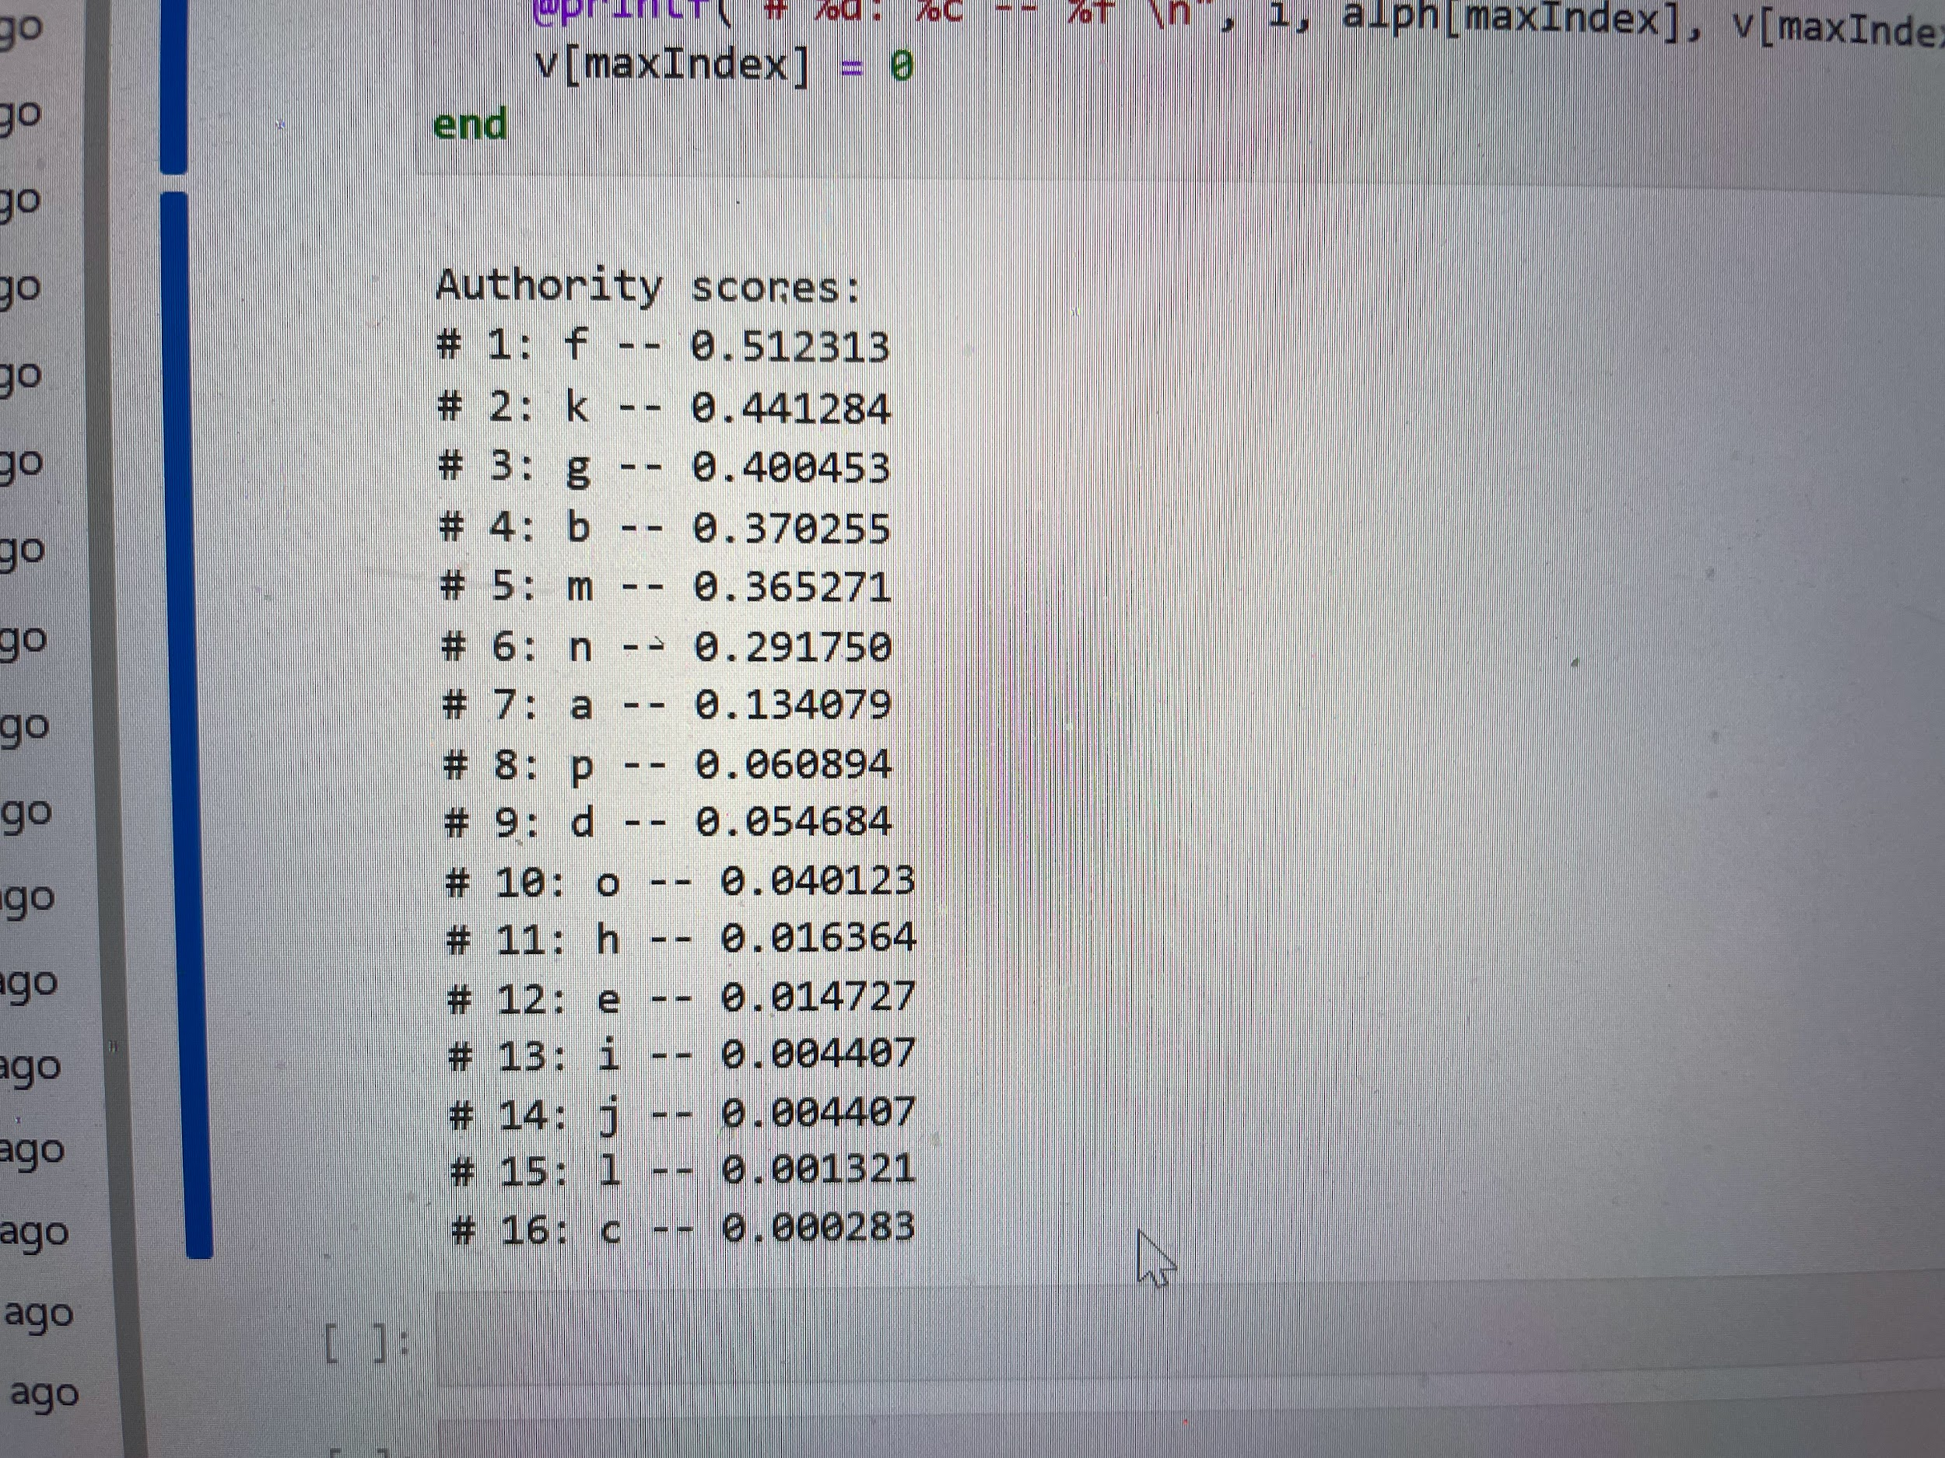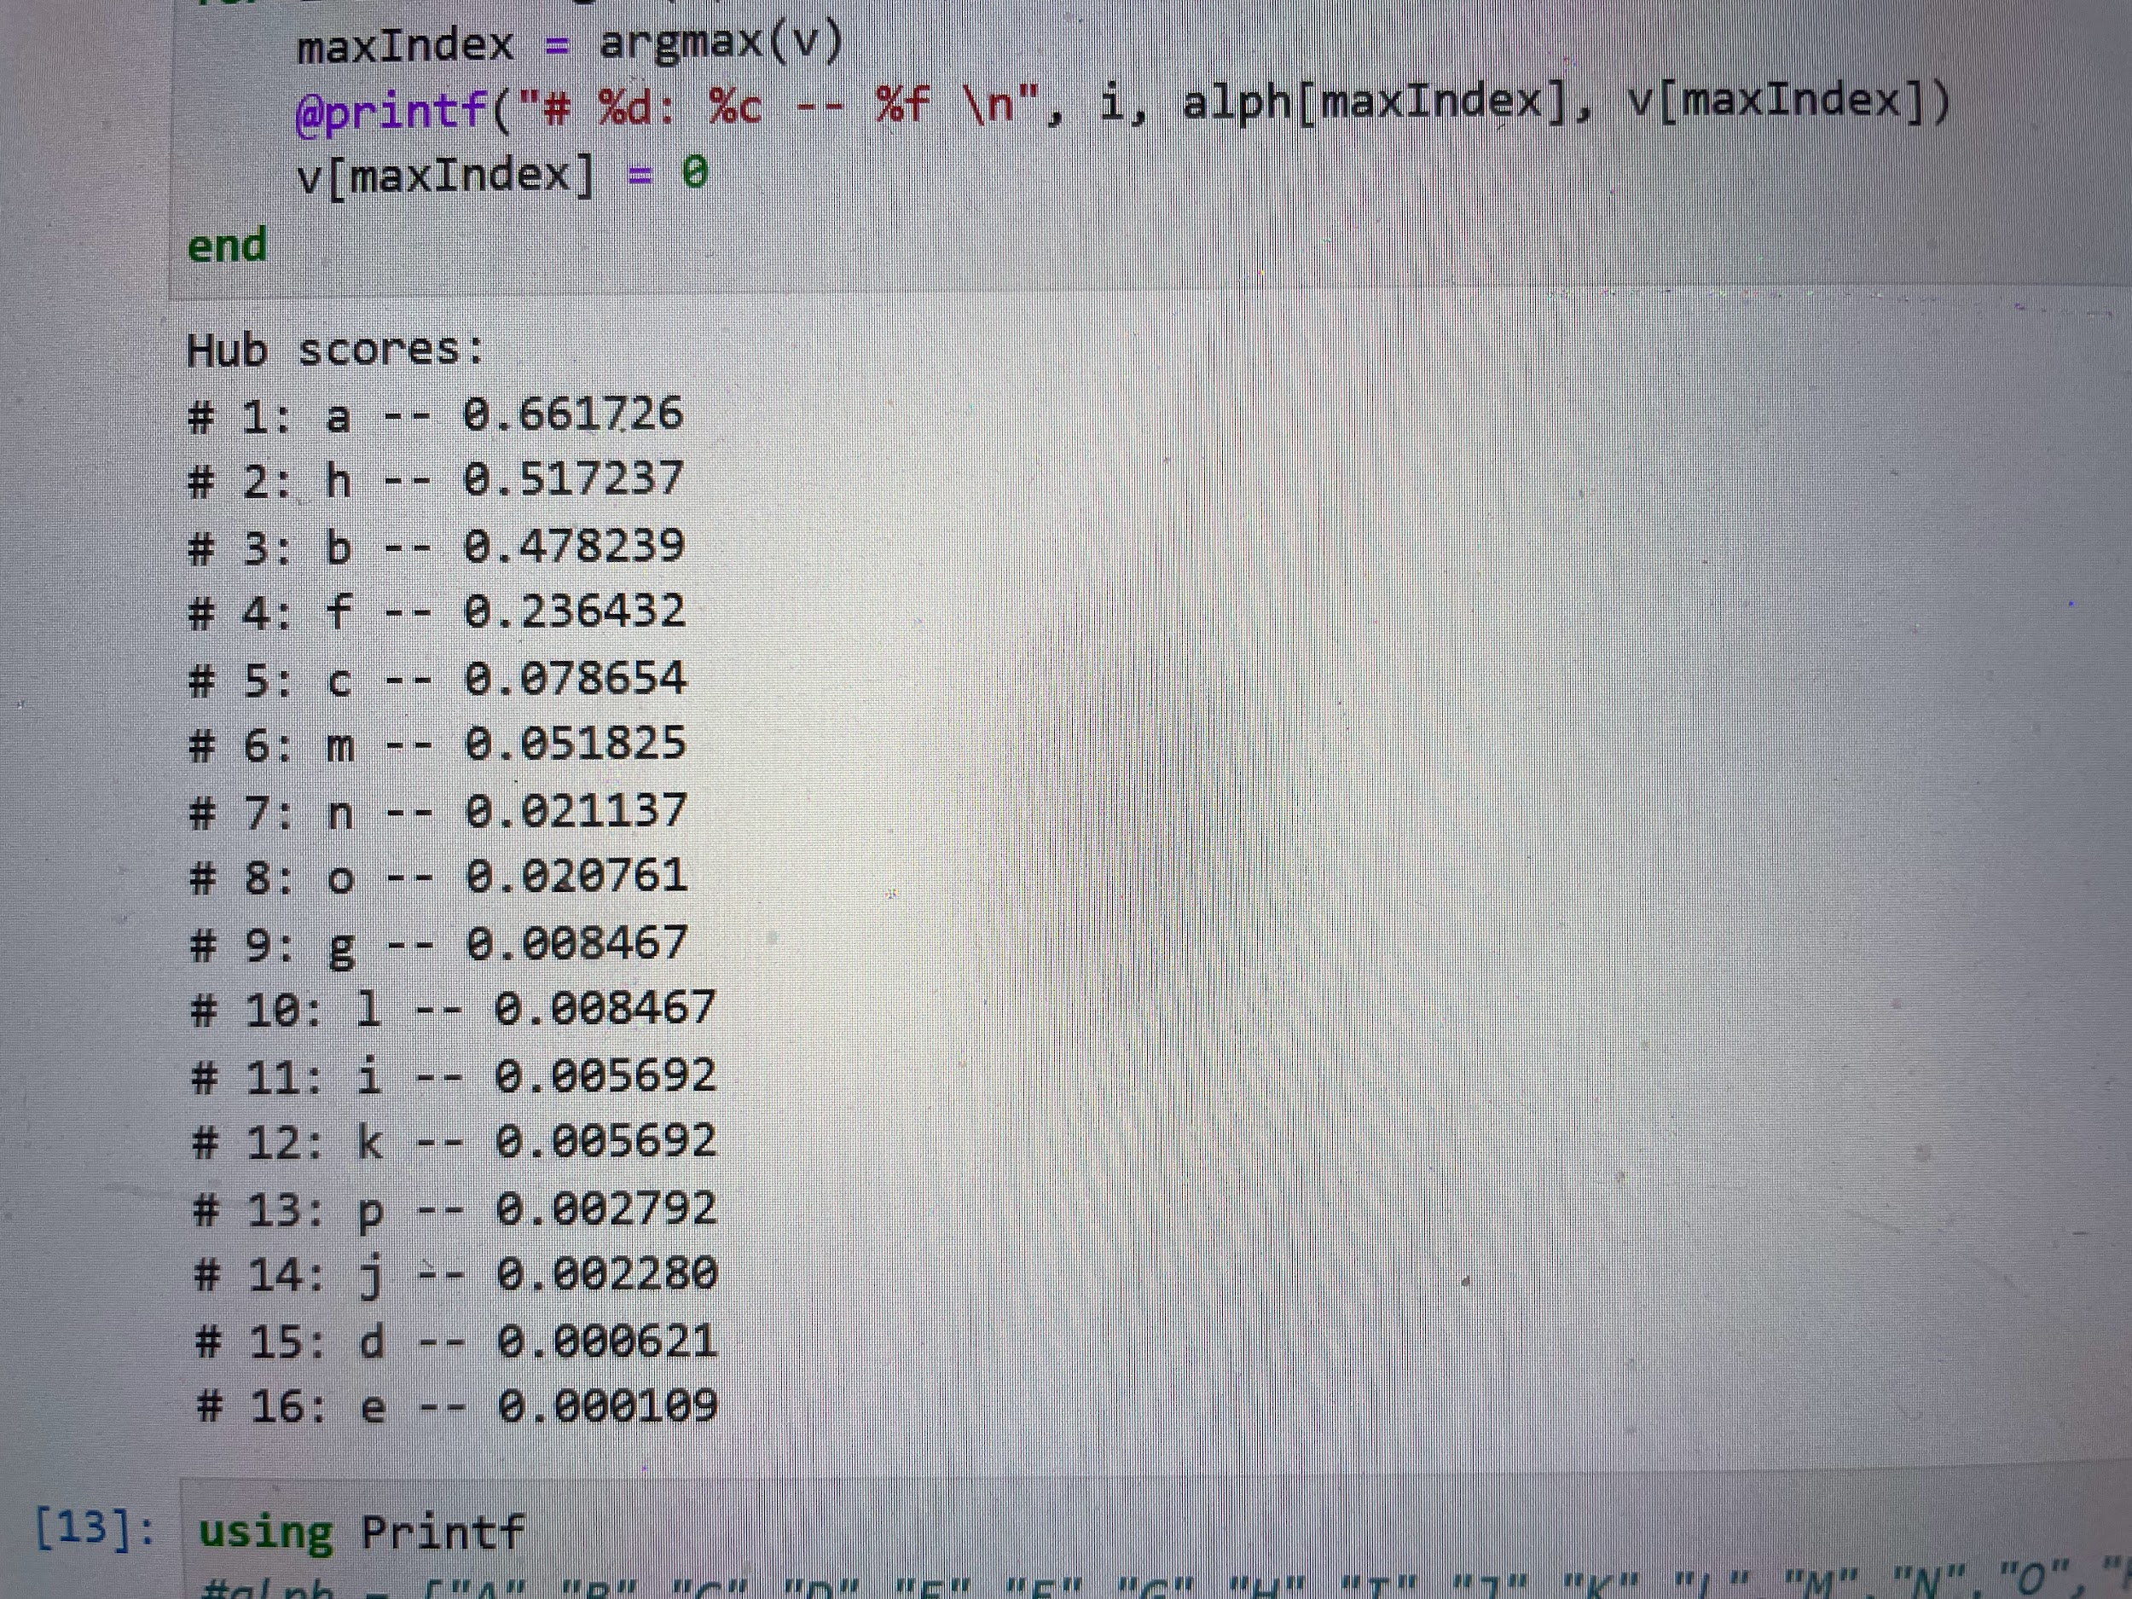

HITS:

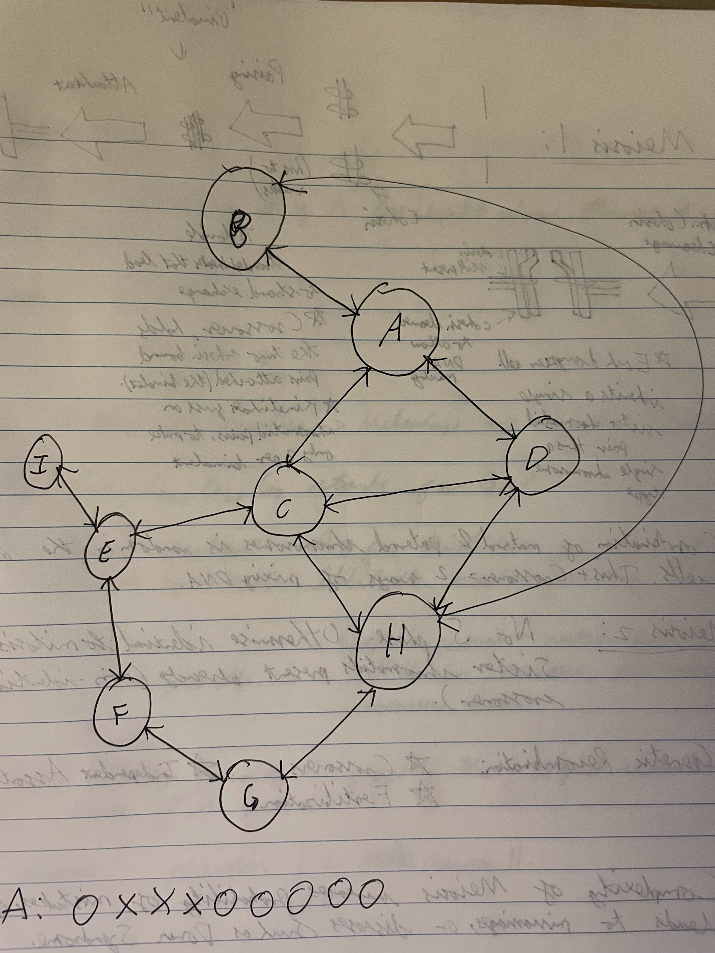

**Example 4**

PageRank:

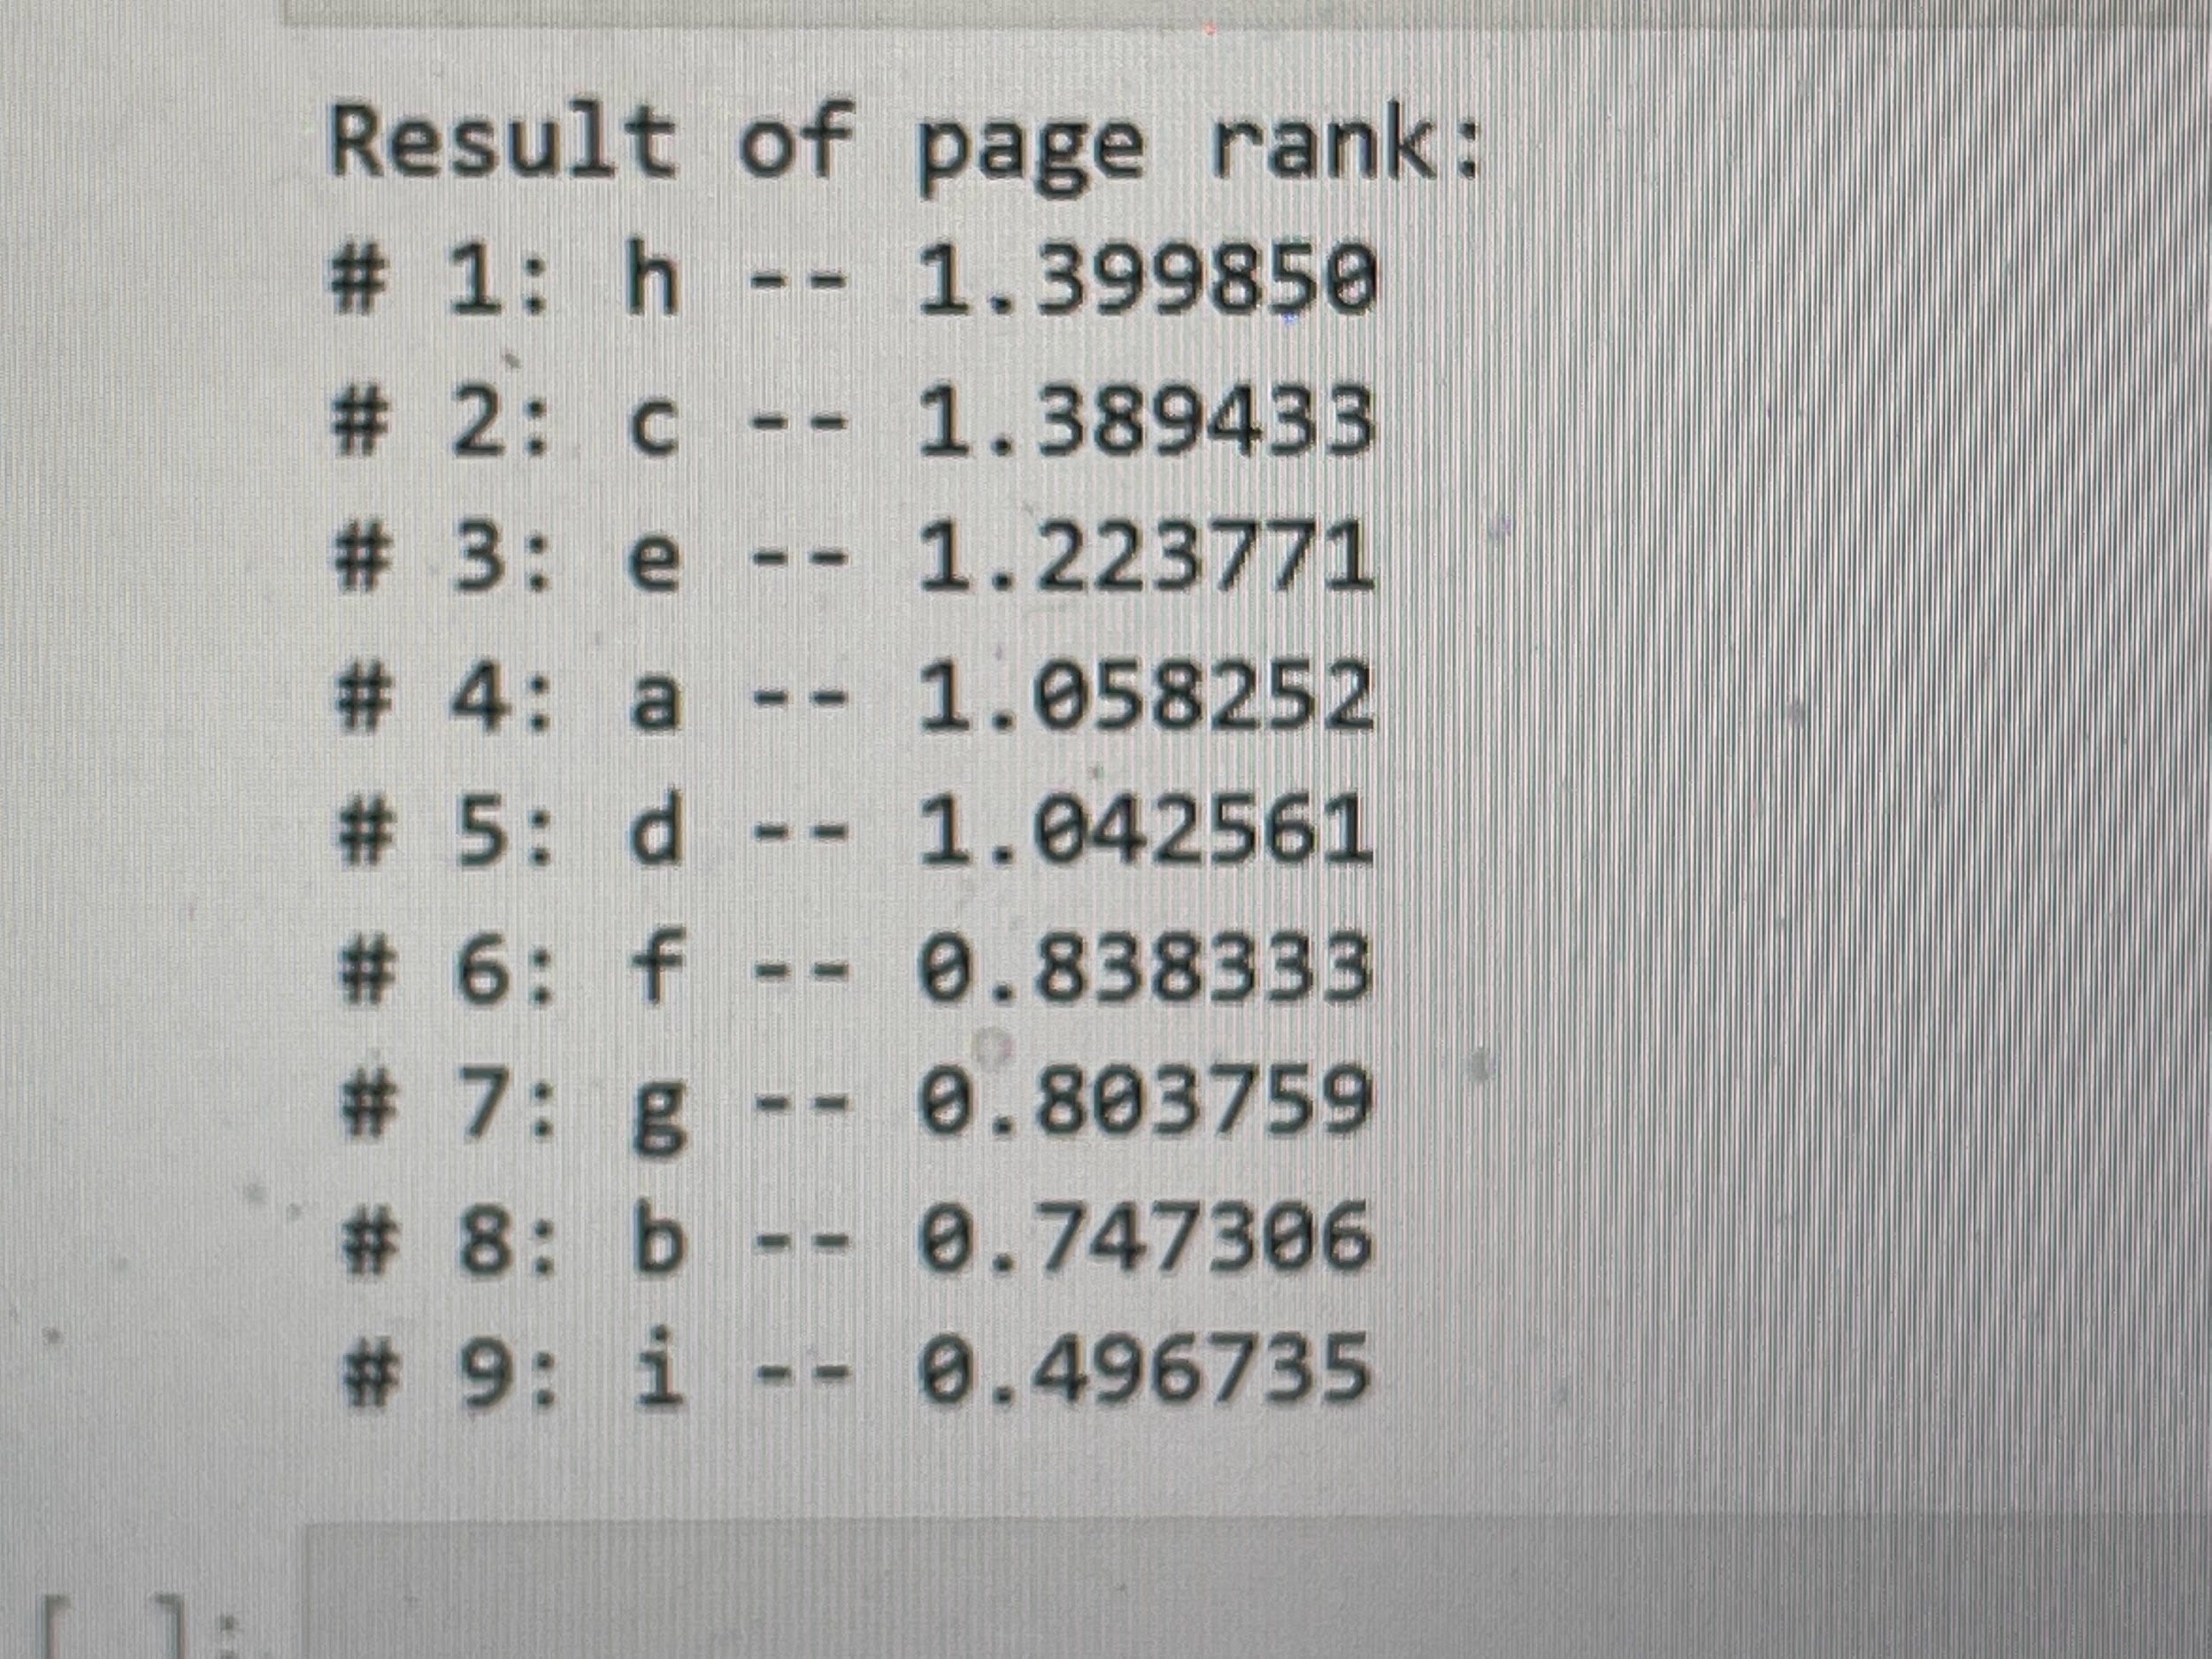

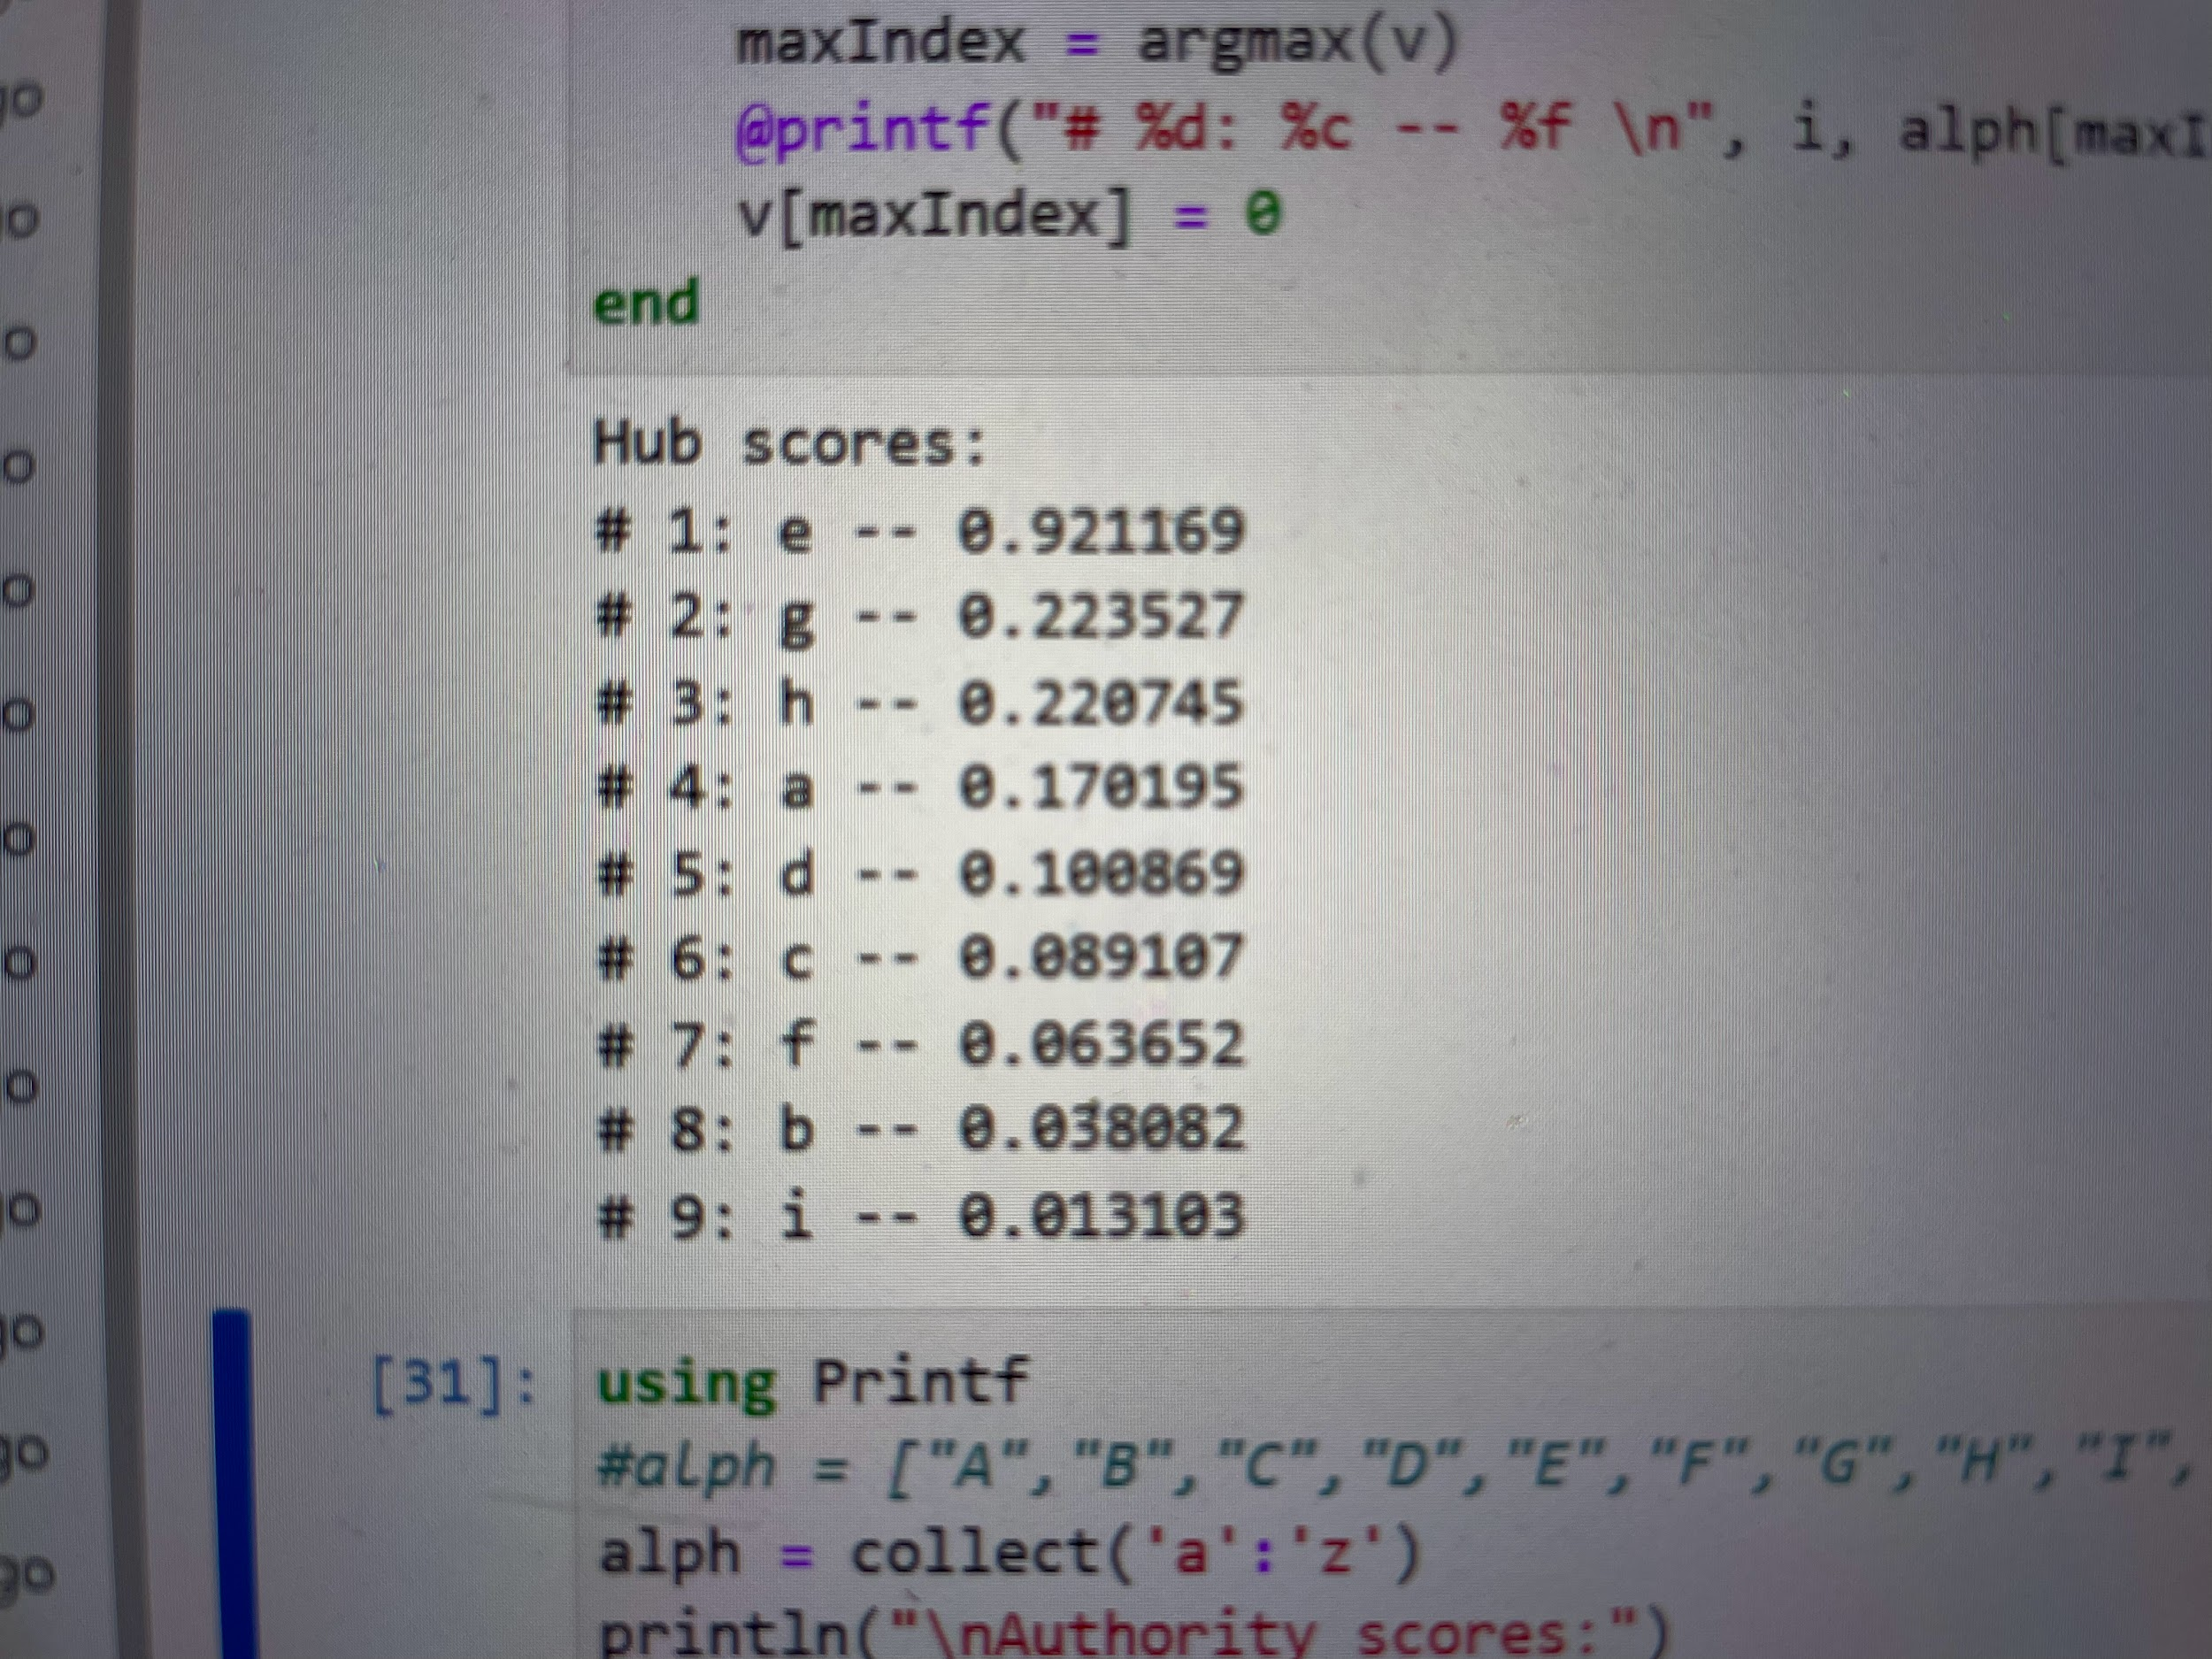

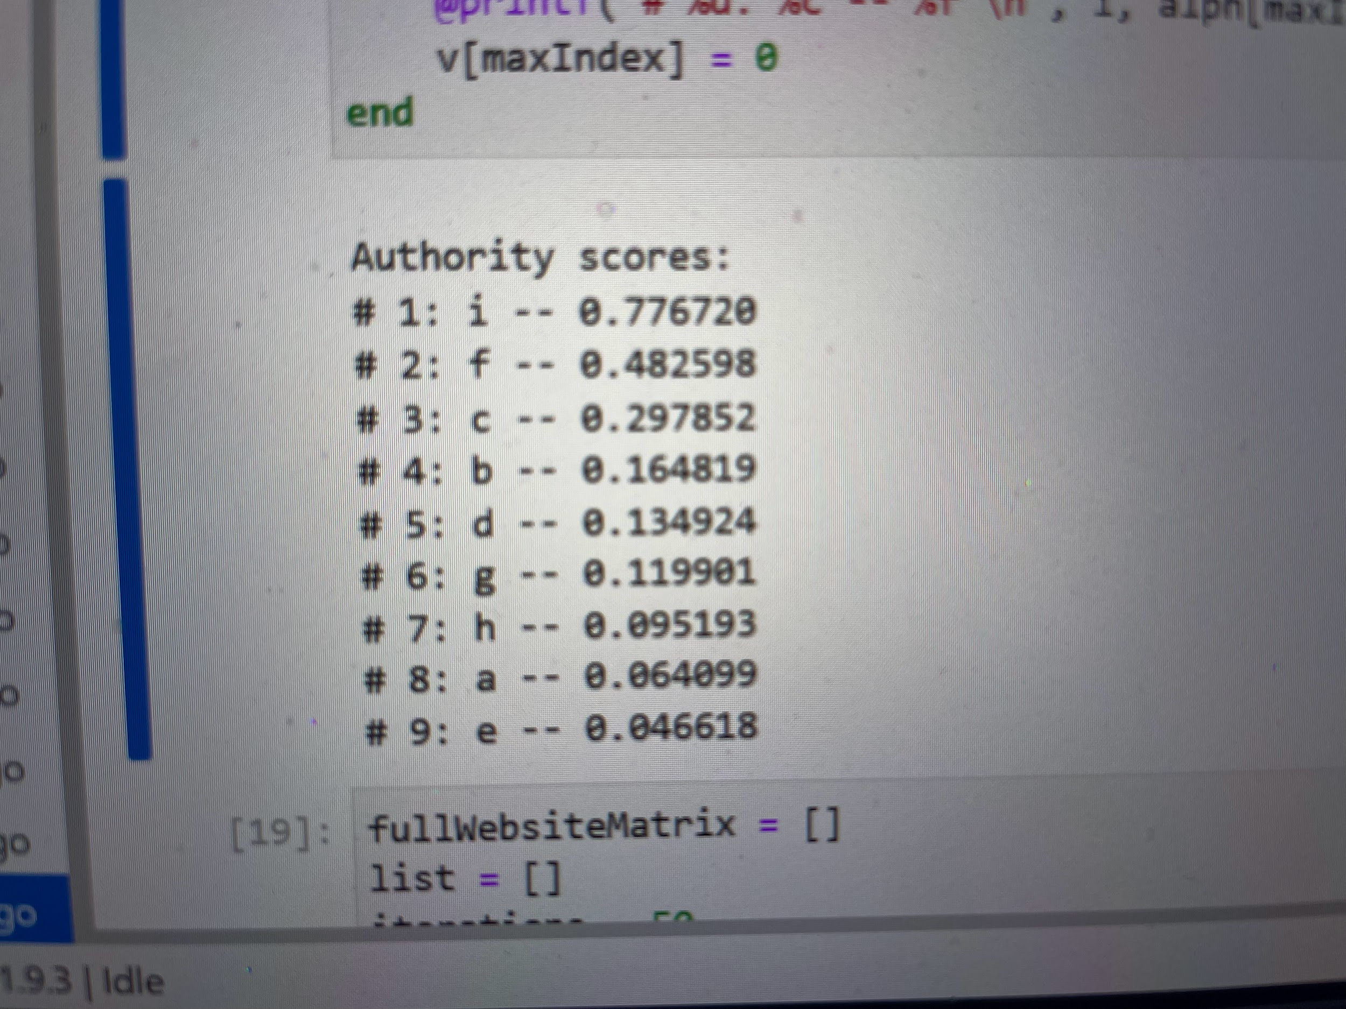

HITS:

